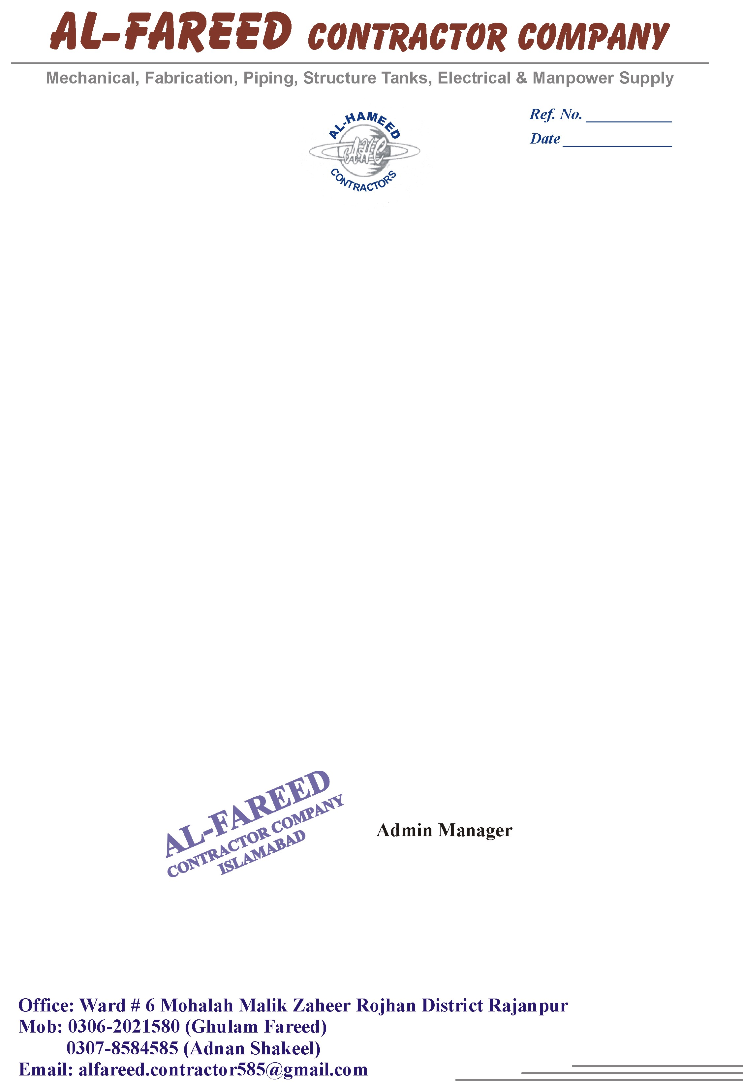

<To>

**TO WHOM IT MAY CONCERN**

It is certified that Mr. <Name> S/O <Designation> CNIC: <CNIC> worked with us as a <Designation> at New International Airport Islamabad from <From> to <To>.

During this period, his services were found satisfactory.

We wish him every success in his future life.